1.

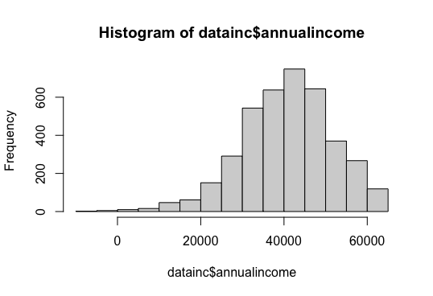

2.

head(datanew)

person_id dbirwt dmeduc race_white cigar6 dmage annualincome

1 1 3997 12 1 0 26 29439.93

2 2 3827 17 1 0 41 57753.68

3 3 3660 99 0 0 43 44600.88

4 4 2124 14 1 0 24 11181.03

5 5 3459 6 1 6 23 54090.66

6 6 3204 14 1 0 25 34249.53

3.

4.

head(datanew)

person_id dbirwt dmeduc race_white cigar6 dmage annualincome low_bwgt

1 1 3997 12 1 0 26 29439.93 0

2 2 3827 17 1 0 41 57753.68 0

4 4 2124 14 1 0 24 11181.03 1

5 5 3459 6 1 6 23 54090.66 0

6 6 3204 14 1 0 25 34249.53 0

7 7 3430 12 1 3 35 52639.11 0

5.

mean(datanew$low_bwgt[datanew$dmeduc == 12])

[1] 0.07935223

6.

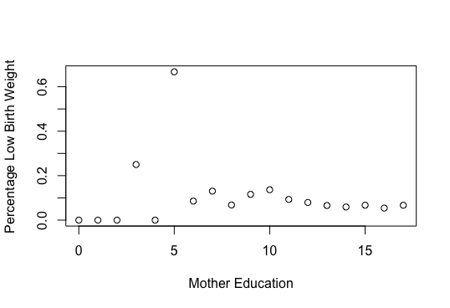

7.

head(datanew)

person_id dbirwt dmeduc race_white cigar6 dmage annualincome low_bwgt aboveHS

1 1 3997 12 1 0 26 29439.93 0 NA

2 2 3827 17 1 0 41 57753.68 0 1

4 4 2124 14 1 0 24 11181.03 1 1

5 5 3459 6 1 6 23 54090.66 0 NA

6 6 3204 14 1 0 25 34249.53 0 1

7 7 3430 12 1 3 35 52639.11 0 NA

Part 2:

1. a.

Based on the data, we can establish that people who have insurance on average have a higher number of doctors’ visits. We can’t say that insurance increases doctors’ visits because that is the argument of causality.

b. No, the only thing that can be confirmed is that there is a correlation between the doctors’ visits and insurance. It could mean that those who have insurance are more likely to go to the doctors’ or those who go to the doctors’ are more likely to have insurance.

c. Yes, from this it can be concluded that as price decreases, the demand for doctors’ visits increases, which creates a downward sloping curve.

2. a.

This suggests that there is a positive correlation between those who receive treatment and the amount of doctor visits and that the demand curve is downward sloping curve.

b. No, causality is harder to confirm than correlation. Theβ shows that there is a relationship between those who received treatment (insurance) had a higher number of doctor visits. It does not necessarily establish a causal relationship.

c. This is the same argument as in part b; therefore, the answer does not change. Just because the observation is that people who are insured on average visit the doctor more does not mean that insurance causes people to see the doctor.

d. The Oregon Health insurance experiment attempts to determine if Medicaid coverage enhances individuals’ well-being. The study uses a lottery system to select people for Medicaid and compares them to the control group. The results of the study found that Medicaid increases the amount of hospital visits; while decreasing out of pocket costs for low-income adults.

Part 3:

1. a. Considering that a “quasi natural experiment” is one in which treatment is chosen based on social or political factors, all Medicare is a quasi natural experiment. Because of the age restriction and all the possible factors that go into the age requirement of 65 (retirement, higher necessity for medical insurance, etc.), the Card article highlights the aftereffects of Medicare and the impact of admission, emergency related or not.

b. Researchers can get around the selection problem by establishing a correlation between hospital admissions during the weekday and age of the individual.

c. Figure 2 (Number of Admissions by Route into Hospital, California, 1992-2002) shows the correlation between age and number of admissions, divided between unplanned emergency department visits and other admissions. Within this graph, we are able to determine that once people turn 65 and join Medicare, the number of unplanned emergency visits and other admissions significantly increases. Unplanned ED visits increased from an approximate max of 6.14 visits before the age of 65 to an approximate max of 6.35 visits after the age of 65. However, the most change noticed was for other admissions. These admissions increased from an approximate maximum of 6.08 admissions before qualifying for Medicare to an approximate maximum of 6.33 admissions.

d. According to the article, one of the limitations of the study was that there was only one focus, medicare population. Similar to other medical insurance policies, Medicare covers outpatient care, prescription drugs, etc. However, this study strictly focuses on doctor visit admissions. The